**GOKULA VARSHINI M**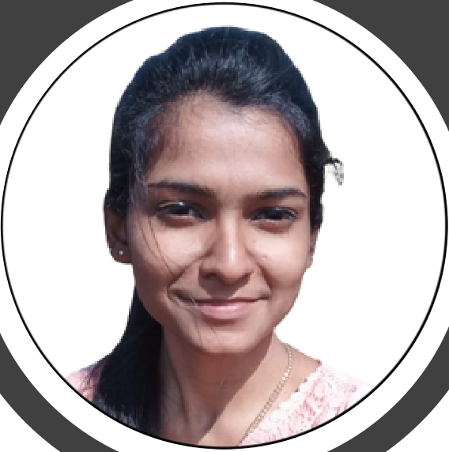

DATA SCIENTIST

**About Me**

As a data scientist, I am committed to staying up-to-date with the latest tools and technologies in the field and continuously improving my skills. I am excited to leverage my expertise to help your organization make data-driven decisions and drive business outcomes.

**Education**

|  |  |  |  |  |  |  |  |
| --- | --- | --- | --- | --- | --- | --- | --- |
| **Contact Me** | | | Karpagam College Of Engineering | | 2020-2024 | | |
|  | 66B, Thalaiyari Ramasamy Street | |
| B.tech Artificial Intelligence and Data Science | | | | |
| Chinnamanur, Theni District | | |
|  | CGPA-9.33 (up to 5th semester) |  | Coimbatore, TamilNadu | |
|  | +91 8098472687 | | Mary Matha Matriculation Higher Secondary School | | | | |
|  | gokulavarshini13@gmail.com | |
| *Higher Secondary Education* | | 2019-2020 | | |
| **Technical Skills** | | |  | Percentage- 82 |  | | Theni, TamilNadu |
| Mary Matha Matriculation Higher Secondary School | | | | |
|  | Unity | |
| *Secondary Education* | | 2017-2018 | | |
|  | Computervision | |
|  | Percentage- 94 |  | | Theni, TamilNadu |
|  | Machine Learning | |
|  | Deep Learning | | **Projects** | | | | |
|  | Natural Language Processing | |
|  | Data Structure | |
| OpenAI - Niva | | Mar,2023-Ongoing | | |
|  | Database Management System | |
| **Technical Languages** | | |  | This project involves developing a chatbot using OpenAI's API. The chatbot | | | |
| will be integrated with a website and will interact with users on topics related to AI. | | | | |
|  | The goal is to create a natural and intelligent conversational interface that | | | |
|  | Python | |
| can provide helpful information and insights to users. | | | | |
|  | R | |  | The chatbot will use natural language processing to understand user | | | |
|  | C | | queries and provide accurate and relevant responses. | | | | |
|  | Java | | Speech Emotion Recognition | | Nov,2023 | | |
|  | C# | |
|  | HTML | |  | This project involves developing a system that can recognize emotions | | | |
|  | CSS | | from speech signals. | | | | |
|  | The system uses Deep learning algorithms and signal processing | | | |
| **Soft Skills** | | |
| techniques to extract features from the audio input and classify it into different emotion categories. | | | | |
|  | Communication | | Automated Fish Species Detection | | Feb,2022 | | |
|  | Leadership | |  | Developed an application that uses TensorFlow and Firebase to automate | | | |
|  | Time Management | | the task of fish species detection. Trained a CNN model on a dataset of fish species images to achieve an accuracy of 90%. Integrated Firebase for cloud storage to store and retrieve images and prediction results.  **Internship**  We&Data | | | | |
|  | Adaptability | |
|  | Problem-Solving | |
|  | Creativity | |
| **Declaration**  Hereby, I declare that the above mentioned details are true and accurate to the best of by | | |
|  | I have done my internship in We&data. They provided me platform to | | | |
| learn PowerBI data visualization tool. | | | | |
| knowledge | | **GokulaVarshini M** |  | I have learnt the ETL process which the fundamental part of Data Analysis | | | |
|  | Created a Dashboard for analyzing the country's financial status. | | | |
| Coimbatore, 21/02/2023 | | |